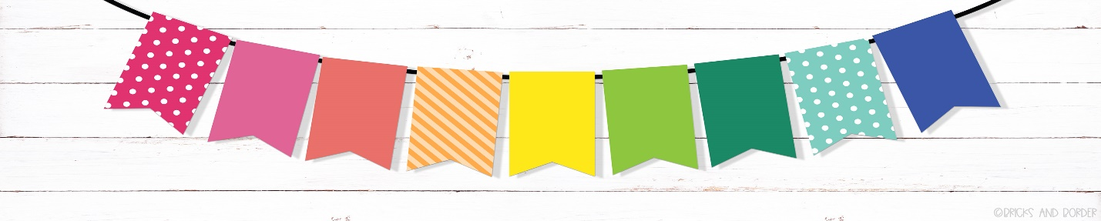
Please label each of these supplies with your child’s name: *backpack (no rolling and large enough to hold a folder) *folder (to hold completed class work)
*water bottle
*snack bag
*head phones labeled (not buds) for chromebooks
*pencil box (approx. 6”x9” – no locks or oversized)
Include in the pencil box:
*box of 16 crayons
*glue sticks (we will keep a community bin for extras)
*scissors
*colored pencils (optional) – NO markers please!
(we will give your student golf size pencils in the class)
Extras for the classroom:
*Clorox cleaning wipes
*tissue *foam soap *paper towel rolls
*tempera paint bottles (red, blue, yellow, peach, lime, teal, brown) *ream of white or colored Xerox paper
*box of crackers (goldfish, graham crackers, cheez-its, etc.) for “uh-oh” emergency snacks
*PE equipment (soccer balls, hand balls, skip it, jump ropes, tennis balls, corn hull sets)
*check Amazon for extras Litel Kindergarten wish list! Thank YOU!

